1. Orchestration Tools: Managing and Scaling Application Servers

(a) How do these tools help manage and scale application servers?
Orchestration tools such as Kubernetes offer a framework for automating the deployment, scaling, and administration of containerized applications. They assist in managing application servers by distributing workloads across a cluster of machines, thereby ensuring high availability, fault tolerance, and efficient resource utilization. Kubernetes dynamically allocates resources to containers according to demand, scaling applications up or down based on predefined policies or current system load.

(b) How do orchestration tools facilitate automated deployment, scaling, and management of application servers?
Tools like Kubernetes automate application deployment through configuration files such as YAML. They monitor application health, automatically restart failed containers, and scale applications based on metrics like CPU utilization, memory consumption, or custom-defined criteria. This reduces manual intervention and supports the maintenance of a stable and resilient application environment.

2. Difference Between Pod, Deployment, and Service
Pod: A Pod is the most basic Kubernetes unit, representing a single instance of a running process within the cluster. It may include one or more containers that share networking and storage resources.
Deployment: A Deployment is a higher-level construct that manages a group of identical Pods. It guarantees that a specified number of Pod replicas are operational and manages updates and rollbacks.
Service: A Service defines a stable access policy for Pods. It provides consistent network connectivity to Pods, even as they are created, removed, or scaled.

3. What is a Namespace in Kubernetes? Provide an example.
A Namespace in Kubernetes is a method for dividing cluster resources and creating isolated naming scopes. It enables multiple users or teams to share a single cluster without conflict. Each Namespace contains resources like Pods, Services, and Deployments, which are isolated from those in other namespaces.
Example: A typical use case involves creating a "development" namespace for development workloads and a "production" namespace for live applications. This separation allows teams to isolate their work and apply distinct configurations and policies.

4. Role of the Kubelet and Checking Nodes in a Kubernetes Cluster
The Kubelet is an agent operating on every node in a Kubernetes cluster. It ensures that containers defined in Pod specifications are running and healthy. The Kubelet supervises container status and manages their lifecycle to maintain the desired state.
To check the nodes in a Kubernetes cluster, use the command:
kubectl get nodes

5. Difference Between ClusterIP, NodePort, and LoadBalancer Services
ClusterIP: Exposes the Service on an internal IP address within the cluster, making it accessible only from inside the cluster.
NodePort: Exposes the Service on a static port on each node’s IP address, allowing external access via any node’s IP and the assigned port.
LoadBalancer: Exposes the Service externally using a cloud provider’s load balancer, which assigns an external IP and distributes traffic among cluster nodes.

6. Scaling a Deployment to 5 Replicas
To scale a Deployment to five replicas using kubectl, execute:
kubectl scale deployment <deployment-name> --replicas=5
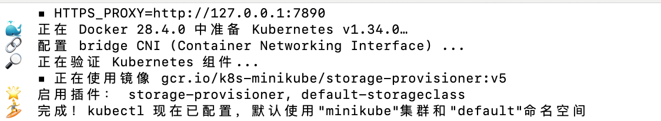

7. Updating the Image of a Deployment Without Downtime
To update a Deployment’s container image without downtime, use a rolling update strategy. Kubernetes incrementally replaces old Pods with new ones, maintaining application availability throughout the process. This can be done with the command:
kubectl set image deployment/<deployment-name> <container-name>=<new-image>:<tag>
This initiates the rolling update.
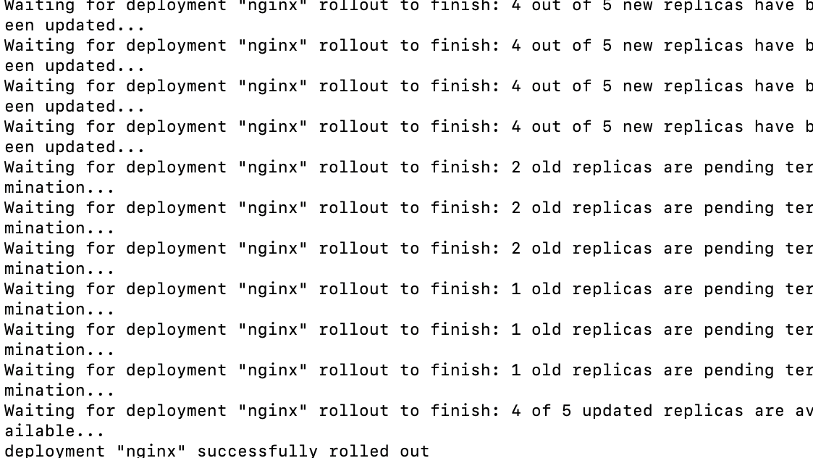

8. Exposing a Deployment to External Traffic
To make a Deployment accessible from outside the cluster, create a Service of type LoadBalancer or NodePort. For example, to expose a Deployment via a LoadBalancer, run:
kubectl expose deployment <deployment-name> --type=LoadBalancer --port=80 --target-port=8080
This command creates a LoadBalancer Service that provides external access.
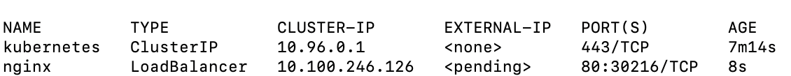

9. How Kubernetes Scheduling Decides Which Node a Pod Runs On
Kubernetes employs a scheduler to assign Pods to nodes in the cluster. The scheduler evaluates factors such as node resource capacity (CPU, memory), affinity and anti-affinity rules, taints and tolerations, and other configured policies. The objective is to optimize resource usage while ensuring high availability and reliability.

10. Role of Ingress and Difference from a Service
Ingress: Ingress is a Kubernetes resource that controls external access to services in the cluster, typically for HTTP/HTTPS traffic. It offers routing based on hostnames, URL paths, and other HTTP rules. An Ingress controller is required to implement the Ingress rules.
Service: A Service exposes a logical set of Pods as a network service, enabling communication between Pods and with external clients. While a Service provides internal or basic external connectivity, Ingress manages advanced external HTTP/HTTPS routing to various services within the cluster.

